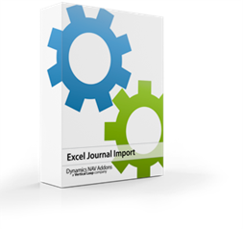
Instantly merge Customers, Vendors, G/L Account, Items, and Dimension Values in Microsoft Dynamics NAV

Do you have duplicate customer cards? Obsolete G/L Accounts? Someone entered the same vendor twice?

Now you can merge them with a click of a button, and all documents, history, and ledgers will update automatically.

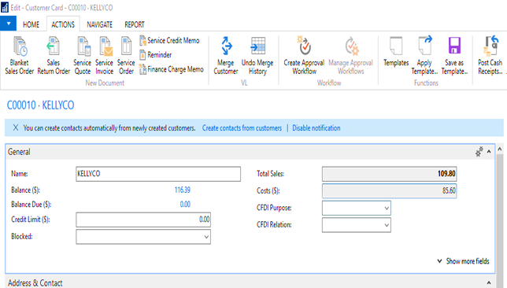

Simply open the source card. In this case, click Merge Customer in the ribbon. Define the destination (target) account.

Click OK and all ledger entries, sales history, Ship-to-Addresses, and Contacts will be merged into the target account.

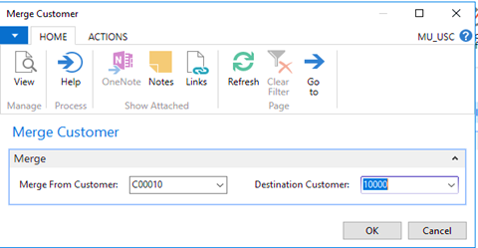

Do you want to undo the merge? Either open the target account and click Undo Merge History or go to the
Merge Utility History List. Click Undo Merge and everything is restored.

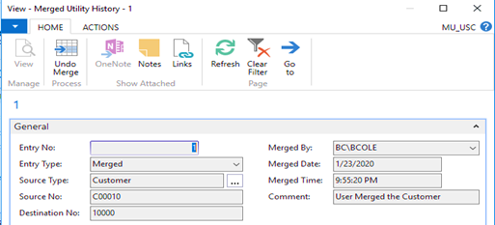
Do you have a lot to merge? You can now “Batch Merge” multiple accounts and get them all done at once. Contact us for a demo and see how in person.

