Partners, please feel free to use this as you see fit.
Here is the product on our website: https://businesscentraladdins.com/1099-toolkit/
Here is the fact sheet: https://businesscentraladdins.com/wp-content/uploads/1099Toolkit.pdf
Please contact me directly for questions / assistance around marketing: mike@dynamicsnavaddons.com
Please contact Bob Cole for ordering, pricing, installation: bob.cole@dynamicsnavaddons.com / +1-407-260-0834

Subject:
- You should know about these new 1099 requirements
- You might not be equipped for 1099 processing this year
- You’ll need this to process 1099s in BizCentral/NAV this year

Preview Text (if applicable):
There is a new 1099 form required by the IRS – you’ll need this add-in to process it in Microsoft Business Central or Dynamics NAV.

Hi [FName],
As we’re getting ready for year-end processing, we realized that the IRS has made a few changes to 1099 requirements this year that could cause some issues for you as you prepare to process your 1099s in Microsoft Business Central or Dynamics NAV.

The government recently created a new 1099 NEC (Non-Employee Compensation) form, replacing 1099 MISC-07. All vendors and reportable payments currently coded as MISC-07 must be re-coded as 1099 NEC and reported on the new form.

While Dynamics NAV 2016+ and all Microsoft Business Central versions have a Regulatory Update available to include the ability to print Form 1099-NEC, any older versions will lack the capability to recode vendors or payments from MISC-07 to NEC and print the new form. In addition, changing those codes (even with the updated version) will likely be time-consuming and tedious. There is also an issue in the systems and their new Regulatory Update where they will inaccurately report unpaid invoice amounts on 1099 forms.

I want to help you avoid getting tripped-up due to this recent change and make your 1099 processing as easy, streamlined, and accurate as possible in your current system. That’s why I think you should take a look at the 1099 Toolkit, which can handle the new 1099 NEC form and is available for various versions of both Microsoft Business Central and Dynamics NAV.

The 1099 Toolkit offers you an easier, quicker, and more-organized way to prepare and print your 1099s, allowing you to:

- Prevent unpaid invoice amounts from being inaccurately reported on 1099 forms
- Change all MISC-07 codes in vendor cards and ledger entries to the new NEC code with one click
- Print and upload all 1099 forms from NAV or Business Central, including the new 1099 NEC form
- Identify and correct vendor Federal ID issues to prevent missing or duplicate forms
- Review reportable 1099 information and quickly make corrections (like changing 1099 codes or separating reportable and non-reportable invoice amounts)
- Preview 1099 information by vendor before printing

See the product overview here. For more information about features and capabilities, take a look at the 1099 Toolkit fact sheet.

[And, if you would like to learn more, join us for an educational webinar on <Date, Time>, that will teach the correct 1099 processing both with and without the 1099 toolkit. You can register HERE.]

Please reach out to me with any questions or interest.

[SIGNATURE]

Social Media Posts:

Links to share our posts:
LinkedIn: https://www.linkedin.com/feed/update/urn:li:activity:6741844446356258816
Facebook: https://www.facebook.com/276170943338119/posts/693259788295897/?d=n
Twitter:
https://twitter.com/bizcentraladdin/status/1336309584814862336?s=20

Copy/Paste posts:
#DidYouKnow the IRS created a new 1099 NEC (Non-Employee Compensation) form, replacing the 1099 MISC-07? To easily process this new form in #Microsoft #BusinessCentral & #DynamicsNAV, you’ll need the 1099 Toolkit add-in. Contact us for more information.

1099 processing can be a hassle. The IRS’s new 1099 non-employee compensation form could trip you up during year-end processing in #Microsoft #BusinessCentral & #DynamicsNAV. The 1099 Toolkit streamlines 1099 processing and is updated for these new requirements.

Don’t get stuck this year due to the IRS’s new 1099 non-employee compensation form. The 1099 Toolkit lets you easily and quickly process all 1099s, including the new form, directly in #Microsoft #BusinessCentral & #DynamicsNAV. Contact us for more information.

#Microsoft #BusinessCentral & #DynamicsNAV has ALMOST everything you need for 1099 processing. To streamline the process and meet the IRS’s new 1099 non-employee compensation form requirements, take a look at the 1099 Toolkit by @bizcentraladdin. Contact us for more information.

Don’t get stuck during 1099 processing this year!
There’s a new 1099 NEC (Non-Employee Compensation) form, and #Microsoft #BusinessCentral & #DynamicsNAV lack capabilities to quickly and easily process it. The 1099 Toolkit lets you process all 1099s, including the NEC form, right in these programs. Contact us for more information.

Social graphics:
#1:
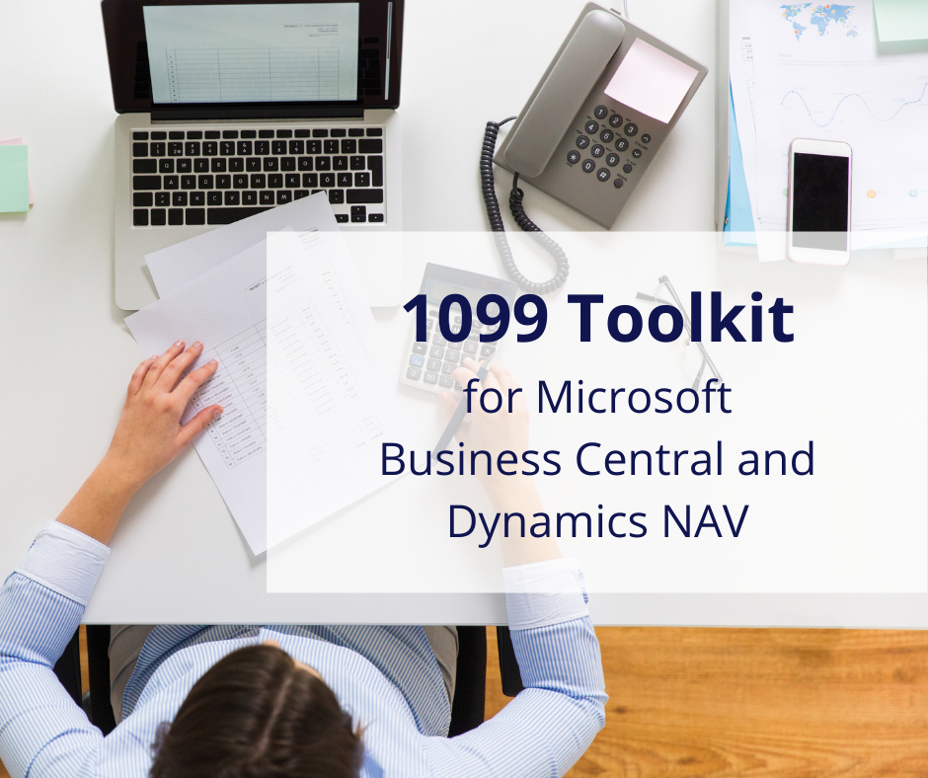
#2:
